Project Background

High on a hill in Nepal at Anandaban Research Centre, pioneering work is taking place to reach the greatest height of all – ending leprosy.

In a crumbling lab on a mountain top, the team are making scientific breakthroughs that will have a global impact.
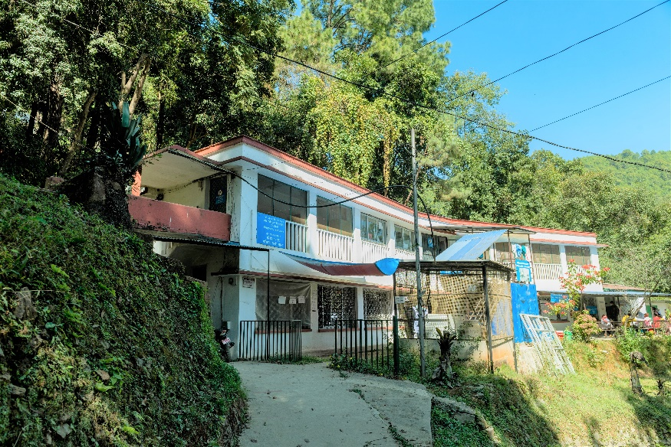
But the lab is now at risk of closing. It was severely damaged in the devastating earthquakes in 2015 and won’t pass the upcoming Nepali Government inspection. Without this lab, the chance to end leprosy in our lifetime will be lost forever.

To save more people from the horrific effects of leprosy, we must build a new world-class research centre at Anandaban, on the roof of the world. With your help, scientific breakthroughs from this lab will end leprosy and lift people affected by this disease up to the great heights they were destined to achieve.

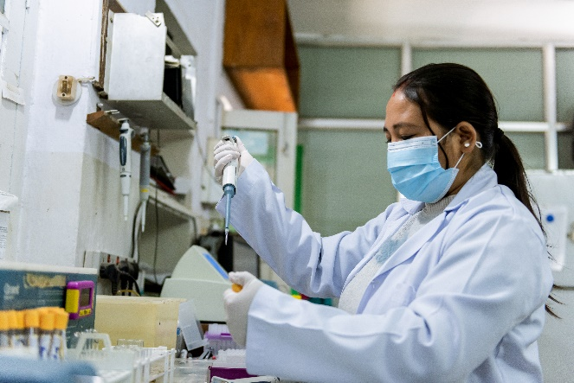
Leprosy is a devastating disease which can rob people of mobility, family, jobs, and dignity. This is why we continue the steep climb to end leprosy forever. The research team at Anandaban has already made huge strides forward in improving treatment, and each day promises even more progress. The path ahead of us leads to our ultimate goal of ending leprosy globally.

We’ve already helped thousands of people affected by leprosy and inspired our medical team to make life-changing discoveries. Now, as the future hangs in the balance, we must go even further. We must rebuild Anandaban Research Centre and make it a place of medical miracles.

Together, we will find new treatments to end leprosy forever. Together, let’s go to greater heights.

Project Activities

First we need the building which will include 8 new laboratory modules, 6m x 3.4m, plus further rooms and a reception area. Over the next two years they will all require equipping. The initial requirement is clearly the bricks, then each lab needs its own air supply and extraction, it will have piping for lab gases and water plus trunking for electrical outlets.

Working Together

God challenges us all to go to greater heights, in His name. Today with your help, the summit of ending leprosy is in sight. When you help rebuild Anandaban Research Centre in Nepal, you will create an opportunity for medical miracles to take place. A world free from leprosy depends on it.

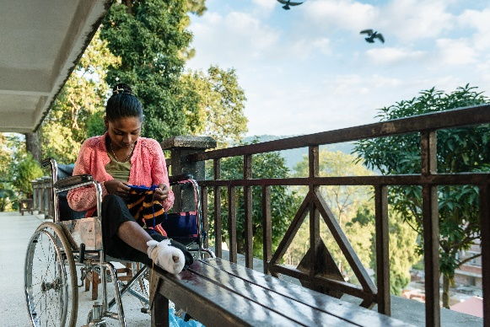
Your support will transform lives for generations to come, helping people affected by leprosy reach greater heights personally.

Jesus calls us to stand with people affected by leprosy. Today, you can make this disease a thing of the past for everyone around the world.

Do you dream of a world where everybody is included? Together we can go to greater heights to make sure everyone feels accepted, not rejected. Together we can finally see miraculous breakthroughs in research and together we can end leprosy!
25,000 Bricks |  | 180
100,000 Bricks |  | 720
15 Bags of cement |  | 105
60 Bags of cement |  | 420
One of 8 Laboratory modules 3.4m X 6.0m |  | 8,000
Various pieces of scientific equipment |  | 11,575
Total |  | £21,000

